**Foundation**

SQL

Module 8

Set Functions – Query reading

© FDM Group Ltd 2017. All Rights Reserved.

Any unauthorised reproduction or distribution in part  
or in whole will constitute an infringement of copyright.

**Document change and version control**

|  |  |  |  |
| --- | --- | --- | --- |
| **Reason for Change** | **Author** | **Date of Change** | **New Version No** |
| Creation of document | Nick Lawton | 26/06/2017 | v1.0 |
|  |  |  |  |
|  |  |  |  |
|  |  |  |  |
|  |  |  |  |
|  |  |  |  |
|  |  |  |  |
|  |  |  |  |
|  |  |  |  |
|  |  |  |  |
|  |  |  |  |
|  |  |  |  |

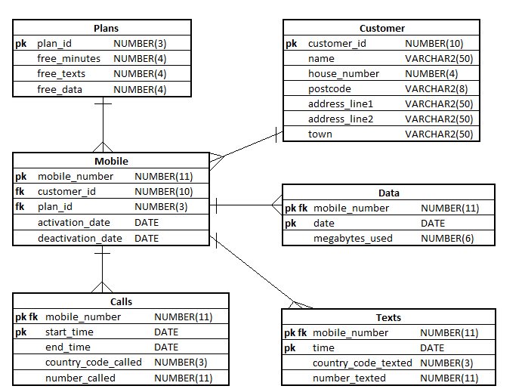

**Exercise 1**

## Describe in simple language what each of the following queries will return:

|  |
| --- |
| **Questions** |
| 1. SELECT mobile_number   FROM calls  MINUS  SELECT mobile_number  FROM data; |
| 1. SELECT mobile_number   FROM data  MINUS  SELECT mobile_number  FROM calls; |
| 1. SELECT mobile_number   FROM calls  INTERSECT  SELECT mobile_number  FROM data  INTERSECT  SELECT mobile_number  FROM texts; |
| 1. SELECT mobile_number   FROM mobiles  MINUS  SELECT mobile_number  FROM calls  MINUS  SELECT mobile_number  FROM texts  MINUS  SELECT mobile_number  FROM data; |

**Exercise 2**

## Explain why the following queries would produce an error:

|  |
| --- |
| **Questions** |
| 1. SELECT name,   customer_id  FROM customer  UNION  SELECT mobile_number  FROM mobile; |
| 1. SELECT mobile_number,   time  FROM texts  UNION  SELECT start_time,  mobile_number  FROM calls; |